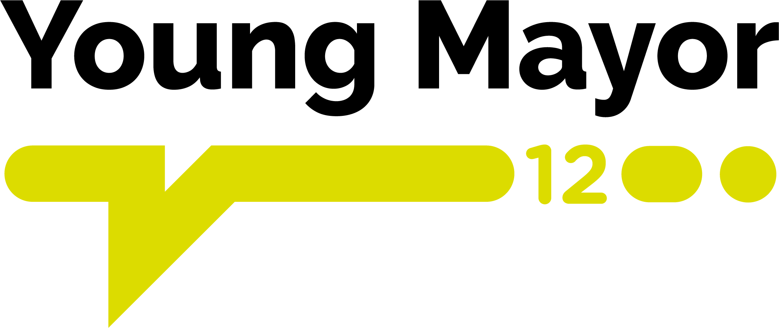

Application Form 2023

To be completed by candidate:

Name
Address
 | Must live in Hull
Postcode
Telephone Number
Email address
Date of Birth | Min age 13 year on 01/01/23
School/college/other

Please answer all the following questions– (please note your responses will be assessed as part of a shortlisting process prior to interview)

Q. What skills and interests do you have that you can bring to this role?

Q. Tell us about the things you do and places you go in your spare time and why?

Q. If selected for this role, would you be available to attend ceremonial duties on weekends, evenings, and school holidays?
Yes  No 

Q. Are you prepared to be a good role model for young people?
Yes  No 

Q. Are you prepared to speak in front of groups of people? Eg HYPP, events, group work.
Yes  No 

Please return this application form to Lisa Wedgner, Kingston Youth Centre, 48a Beverley Road, HULL, HU3 1YE or by email lisa.wedgner@hullcc.gov.uk by Friday 21 October 2022

