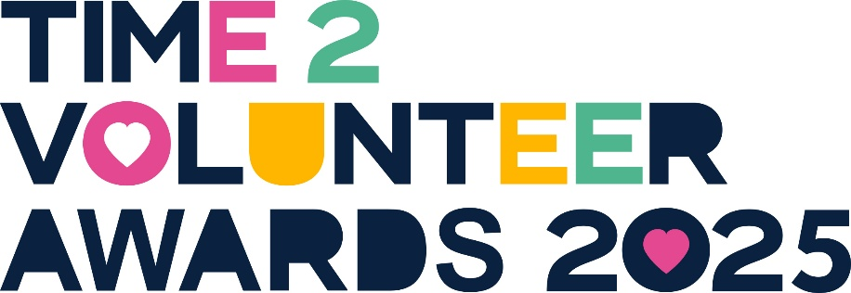

**Time2Volunteer Awards 2025**

**Nomination Form**

Proudly brought to you by HEY Smile Foundation and partners, Hull CVS, East Riding of Yorkshire Council, Hull City Council and CHCP.



Volunteers in our community do the most amazing things! We want to recognise these inspiring people for the fantastic work they do, by celebrating the power of volunteering.

Please nominate people from Hull, East Yorkshire and North & North East Lincolnshire who have volunteered in the last 12 months, since May 2024 (unless it’s for the Founding Volunteer or Long-Serving Volunteer categories).

Your nomination will be judged on the quality in terms of volunteer impact only, not on the number of nominations received for the same person. Please sit back with a cuppa, include as much information as possible, and tell us about an amazing volunteer you know!

It’s free to nominate and all shortlisted nominees will receive two complimentary tickets to an Awards ceremony and celebration at the DoubleTree by Hilton, Hull on Wednesday, 8 October 2025, 13:00 – 16:30. Extra tickets can be purchased at £20 per person.

Nominations are open from 22 May until 13 July 2025.

Provide details of how long they have been a volunteer for, total number of volunteered hours per week / month / past 12 months (since May 2024), and how they fit volunteering into their life.

[Grab your reader’s attention with a great quote from the document or use this space to emphasise a key point. To place this text box anywhere on the page, just drag it.]



May 2024



Please return this nomination form to the address below.

HEY Smile Foundation

c/o Gosschalks  
61 Dock Street  
Queens Gardens  
Hull  
HU1 3AE